**SCREENSHOTS OF SQL QUERIES**

1.Use SELECT, WHERE, ORDER BY, GROUP BY

--Total Profit by Country (ordered descending):  
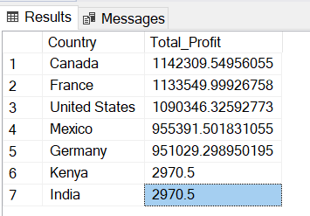

--Sales in January 2019 only:  
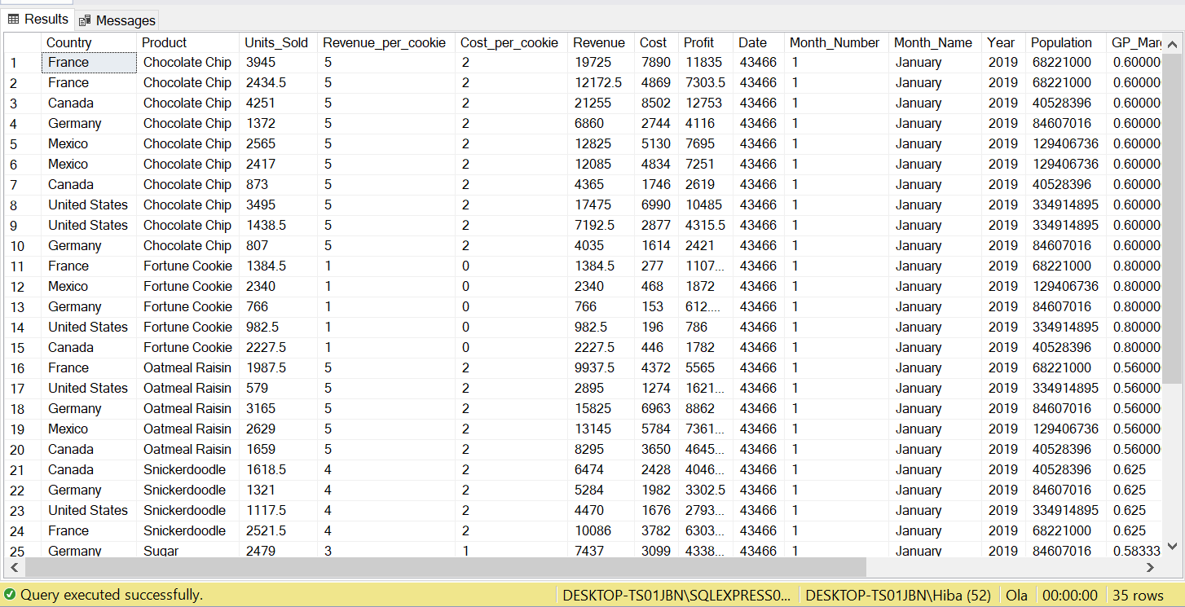

**2.Joins**

**-- INNER JOIN Example** (Joining Sales, Countries, and Products):  
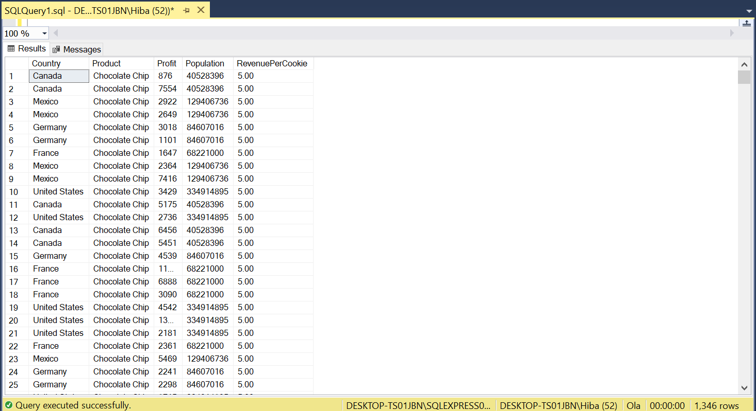

**-- LEFT JOIN Example** (Showing all Sales with matching Products):

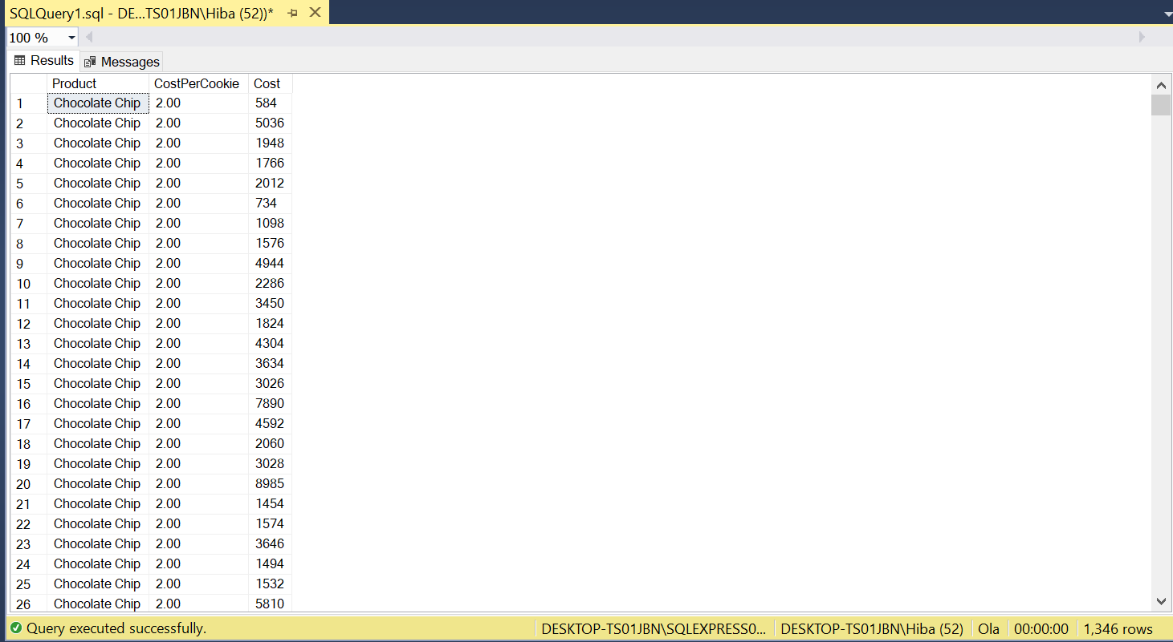

**-- RIGHT JOIN Example** (Showing all Products with matching Sales):  
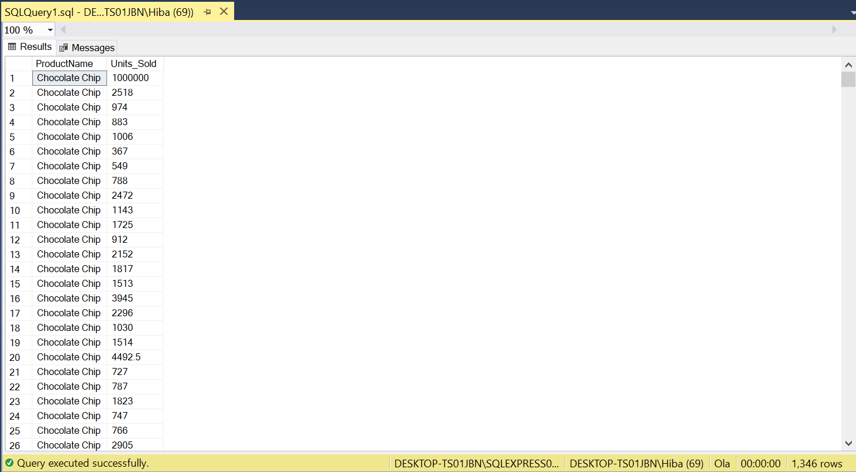

**3. Write Subqueries**

**-- Countries with Profit > Average Profit:**

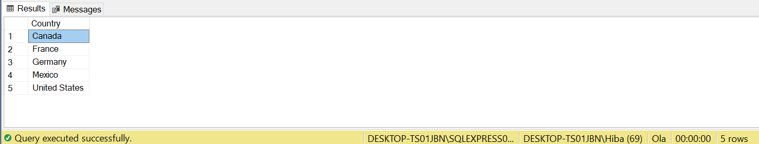

**4. Use Aggregate Functions (SUM, AVG)**

**-- Average Profit per Product:**

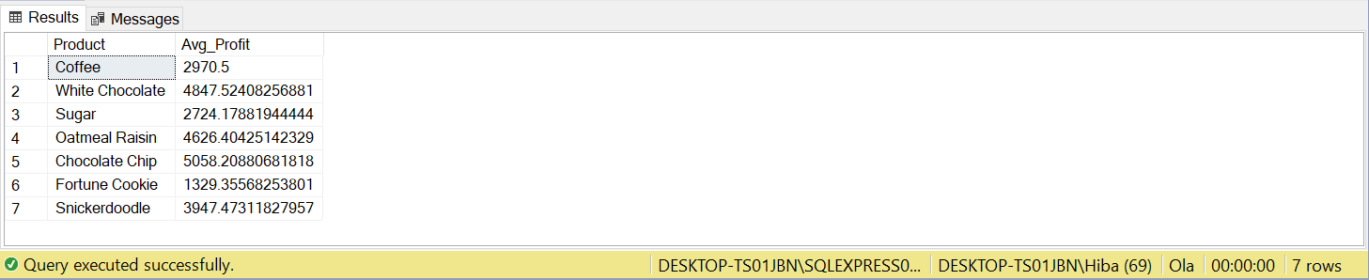

**--Total Revenue and Cost by Month:**

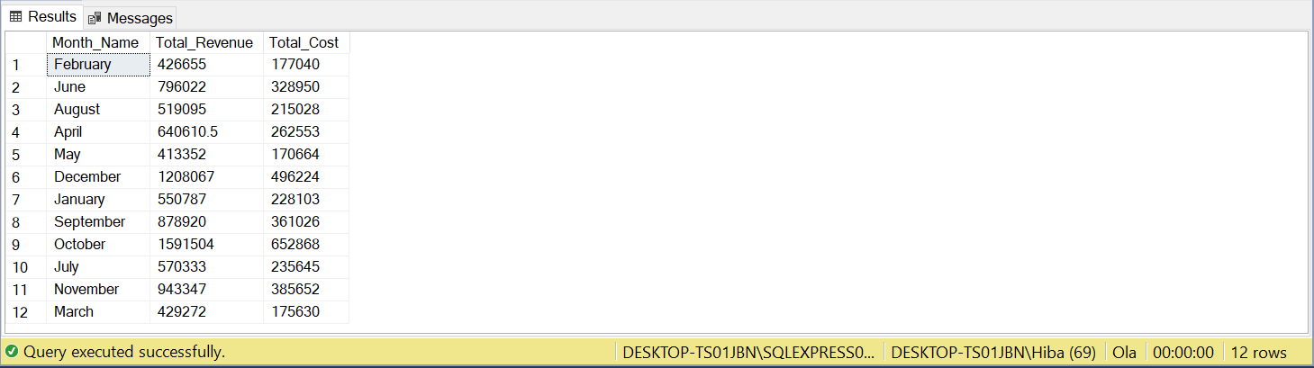

**5. Create Views for Analysis**

**-- Monthly Summary View:**

